Task 3 Hologrphic Layout
Using the demand from task 1 and 2, we got the per part demand to cater to XXX % service levels for both clients A and B together. Using that as the input and table of steps by equipment for each part, we got the equipment needed for processing each part considering a functional organization.
Operating Assumptions Used
Schedule: 5days/week, 2shifts/day(recommended), 8hours/shift
Efficiency: 90%
Reliability: 98%
Effective Availability: 88.2% (0.90 × 0.98)
Availability per equipment:
- 1 shift: 2,116.8 minutes/week
- 2 shifts: 4,233.6 minutes/week
Key Characteristics:
The freestyle layout divides the traditional design canvas into a number of flexible visual fields. These fields are able to present the whole content in a way that they place emphasis on dynamic flow and creativity rather than rigid alignment. In contrast to having a design constrained within a single, rigid grid.
Characteristics
- Flexible: The design is composed of elements that can be positioned intuitively and creatively without the constraints of columns or rows.

- Visual Flow: As elements are introduced, the visual path is shaped by the design itself rather than a simple linear progression.

- Dynamic: Elements can be added or removed, as the design is not confined by a static grid or fixed template.

- Engaging: Content can be overlapped, angled, or varied in size for visual interest and impact.

Distance between each centre :

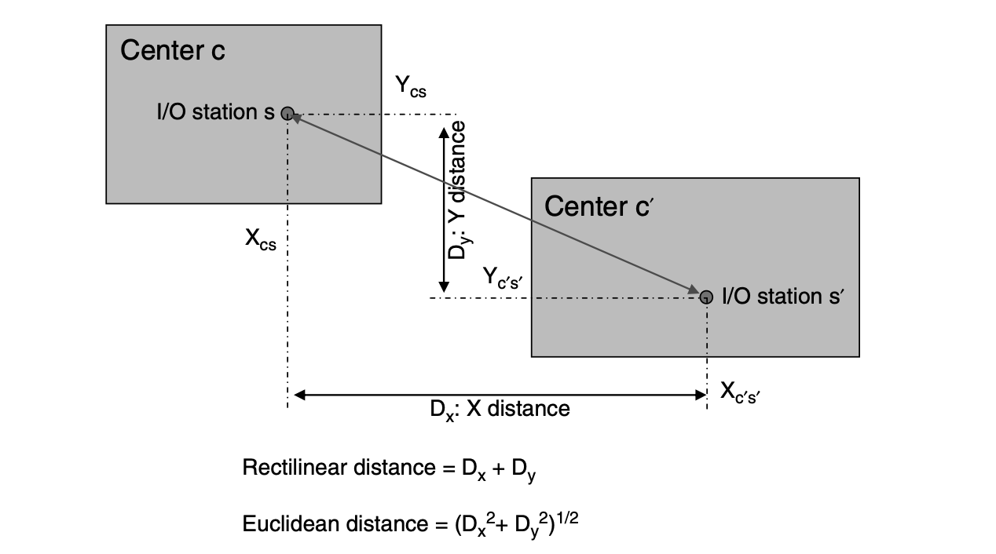

Output of various steps used to create a freestyle layout;
- Used the best way to reduce the area and flow to improve the KPIs in the freestyle and here it incorporates best of all the layout individually.
freestyle and here it incorporates best of all the layout individually.
In this freestyle it has combined both the part layout and the functional layout combining them to reduce the flow and reduce the complexity of multiple lines.

Final layout of freestyle:
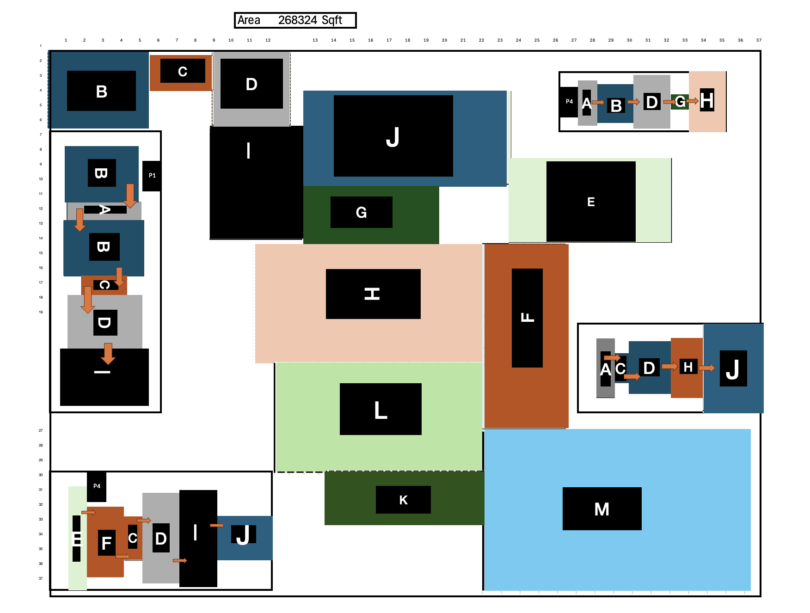

Overall Distance and flow matrix :
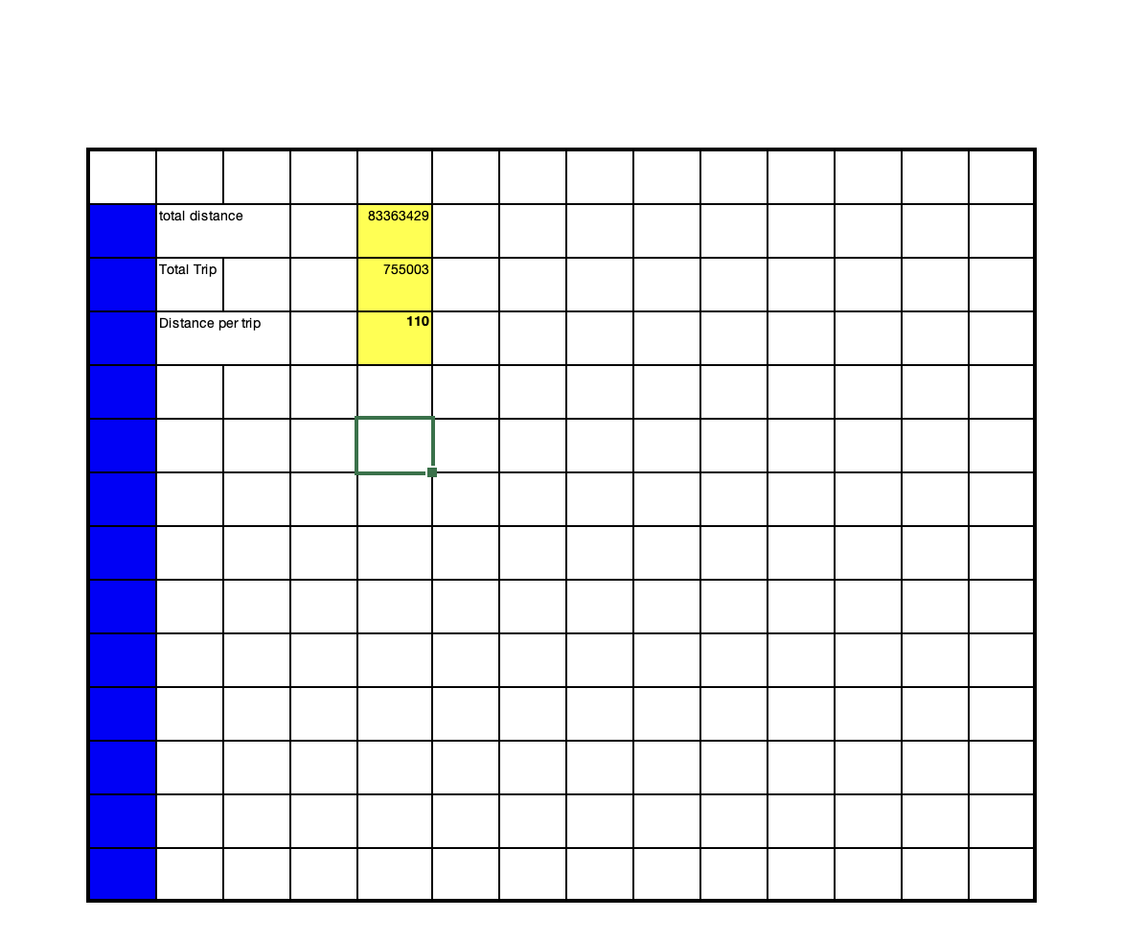

Overall cost calculation:
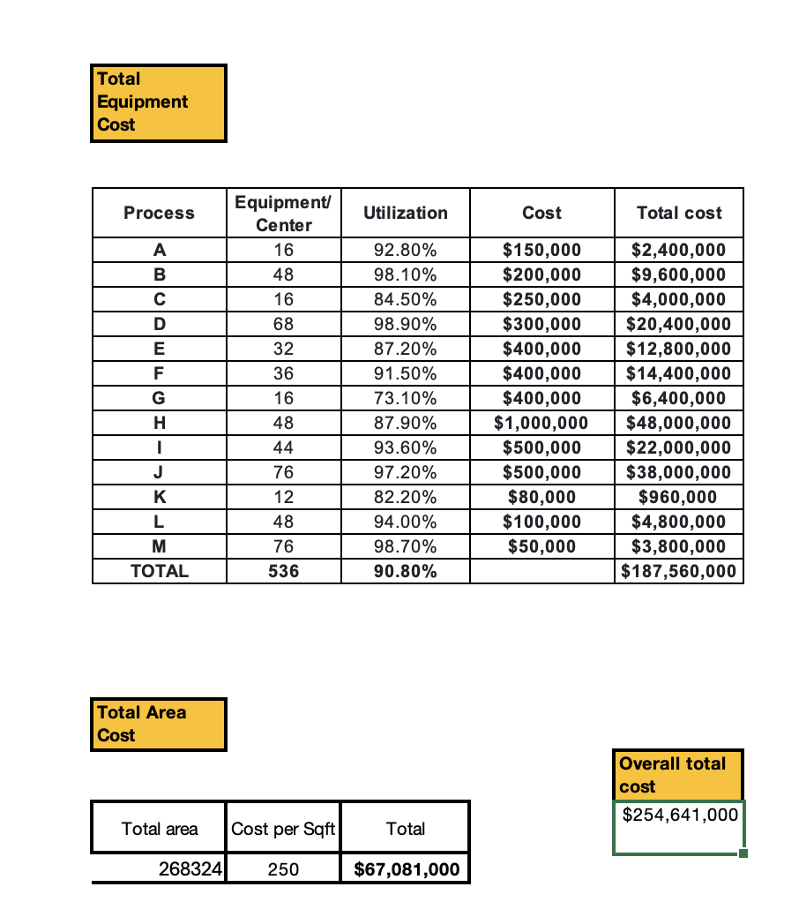

No of operators:
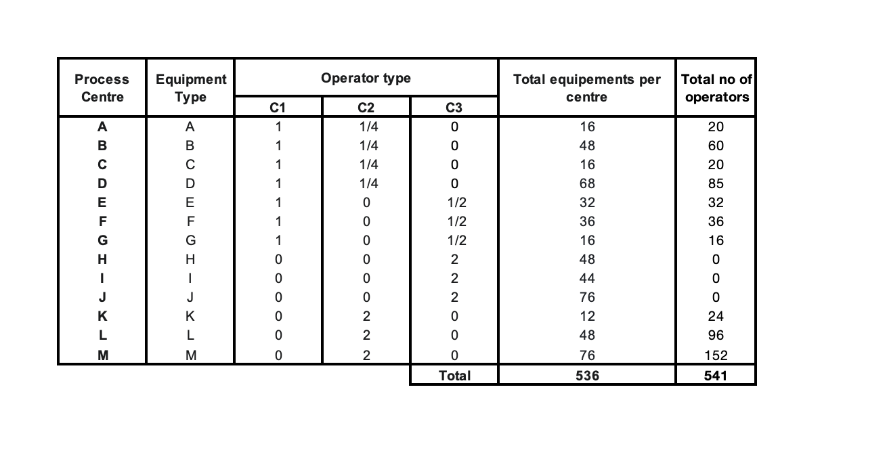
No of eqp | investment $ (combining eqp and area) | Area (sqft) | Distance per trip (ft/trip) | Number of operators (#) | Overall Utilization
400 | 254641000 | 268324 | 110 | 541 | 90.8

